Asian Games: Indian Women take historic Bronze in Badminton

September 22, 2014
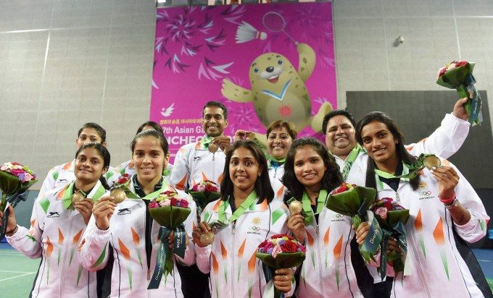

(Members of India's Bronze Medal winning Women's Badminton Team,
Saina Nehwal, P.V. Sindhu, P.C. Thulasi, Ashwini Ponnappa, Sikki Reddy
and Pradnya Gadre with Coaching staff during the Medal Ceremony at the
17th Asian Games at Incheon, South Korea on 22-09-2014)

Incheon: Ending a 28-year-old Medal drought in Badminton at the Asian Games, India Sunday settled for the Bronze in the Women's Team event going down tamely to hosts South Korea in the Semi-finals at the Gyeyang Gymnasium here.
Though World No.7 Saina Nehwal gave India a good start by winning the first singles, her compatriots went on to lose the next three ties and go down 1-3 in the last-four clash.

This is India's eighth Bronze at Asian Games Badminton after having claimed one in 1974 Tehran, five in 1982 New Delhi and one more in 1986 Seoul. This is also India's second ever Medal in Women's Team event after clinching a Bronze 32 years ago at home.
It was going fine for India when Saina continued her good run to overcame World No.4 Ji Hyun Sung 21-12, 10-21, 21-9 in 58 minutes. Though Saina had a 4-1 record before their encounter.
Hopes were high from Double World Championship Bronze medallist P.V. Sindhu when she took on World No.6 Yeon Ju Bae but the South Korean girl, with the vociferous support of the home crowd, delivered a brilliant performance to steal the match away from the Indian. Though the tall and lanky Indian won the first game 21-14, Yeon came back strongly to clinch the marathon one hour and 19 minutes contest by taking the next two games 21-18, 21-13.
Thereon, it was too much to ask from the Doubles combine of N. Sikki Reddy and Pradnya Gadre and P.C. Thulasi in the third Singles to defeat much higher-ranked opponents -- they went on to lose their respective matches, easing the way for the hosts to reach the final. Sikki and Pradnya lost their 45-minute battle 16-21, 17-21 to Kim Soyeong and Chang Yena while Thulasi could not put up much of a fight and lost 12-21, 8-21 in 37 minutes to Kim Hyomin.
------------------------------------------

Incheon, South Korea (22-09-2014)
Members of India's Bronze Medal winning Women's Badminton Team
at 17th Asian Games - 2014

(,

